Capital Area Chapter of PennAEYC
Scholarship and Tuition Assistance Program
Updated August 2023

WHAT is the Scholarship/Tuition Assistance Program?
The Scholarship/Tuition Assistance Program is designed to promote continuing education opportunities to individuals employed in an early childhood education program by awarding one $500.00 scholarship per year.

WHAT Continuing Education Opportunities are Eligible for Scholarships/Tuition Assistance?
Funds are awarded, as a reimbursement, towards any of the following:
A college course completed with a passing grade. The course must be one that is required to complete an early childhood degree or credential or a course in a related field/major/degree that is included on the PA Keys to Quality Early Learning Career Pathway https://www.pakeys.org/career-pathway/
- Director or School Age Credential coursework (PA Key approved) or renewal
- CDA course instruction (for credit or non-credit)
- CDA assessment fee (if not eligible for PA Keys CDA Assessment Voucher Program)
- CDA renewal course instruction and application fee
- Education-related expense fees, such as technology fees, course fees, or books
Applications to other tuition assistance programs must be requested before making an application for the CACPennAEYC Scholarship Tuition Assistance Program. Find information about tuition assistance programs at: https://www.pakeys.org/get-professional-development/financial-assistance/

The number of scholarships awarded is based upon the financial resources available to the Scholarship/Tuition Assistance Program. In the case of limited funds, awards will be prioritized as follows: CDA or Director’s Credential, AA, BA or BS, MA or MS, PhD.

WHO Can Apply?
- Applicants must be a current NAEYC/PennAEYC member- https://www.naeyc.org/get-involved/membership/join
- Applicants must be employed for at least 20 hours/week in an early childhood program. Programs may be public, private, family or group child care, including children birth through age 8.
- Applicants who work directly with young children in early learning settings will be prioritized.
- Those applicants who are working in other programs that support young children will be considered on an individual basis, as funding allows.

WHEN Can I Apply?
- Members may apply at any time during the year.
- Assistance may be for one or more courses in one or more semesters/year, not to exceed $500 awarded per year.
- Awards will be distributed in 60 – 90 days after the application is submitted, once approved by the board.

HOW Do I Apply?
- Review the Application Instructions Checklist to understand the process.
- Collect your transcript with completed grade(s), Student Schedule Bill and all receipts.
- Apply for other tuition reimbursement opportunities first, if eligible: Rising STARS, TEACH, CDA Assessment Voucher (if appropriate). Refer to the link above: “Financial Assistance.” Collect appropriate documentation.
- Make sure your application is complete and submit either online to cacpennaeyc@gmail.com or hard copy to: CACPennAEYC, P.O. BOX 6182, Harrisburg, PA, 17112.

WHAT if I Have Questions?
Contact: Pam Blazi at pamela@growingadventures.net
Capital Area Chapter of PennAEYC holds the right to change the scholarship application process at any time.

CACPENNAEYC SCHOLARSHIP TUITION ASSISTANCE
APPLICATION INSTRUCTIONS AND CHECKLIST

Applications are eligible for consideration ONLY if all items from the checklist below are included in the submitted application packet.

Application Packet Must Include:

__________ Proof of NAEYC Membership Become a member here

__________ Proof of PD Registry participation, if applicable

__________ Copy of transcript for each course
- Must include: name of educational institution; major or degree of study; course title; grade received; date.
- Highlight course(s) on transcript for which reimbursement is sought.
- If your transcript does not include your major or degree of study, please
include your degree plan or a letter from your college advisor, with contact
information included, stating your major or degree of study.

__________ Completed and signed “Application Information” pages of application (page 3 and 4)

__________ Completed “Employee Reference” form (page 5)

__________ Copy of DHS license or certificate for Family or Group Child Care Homes

__________ Copy of CDA transcript or renewal document for CDA Reimbursement

__________ Copy of Director or School Age Certificate transcript and proof of payment for Director or School Age Credential reimbursement

__________ Copy of student bill with highlighted course title and tuition

__________ Copy of receipts from other tuition assistance programs: Rising STARS, TEACH
and/or CDA Assessment Voucher Program, if applicable

__________ Copy of receipts for education-related expenses

__________ For reimbursement of non-early childhood courses in a related field that are not
part of a degree plan, provide a letter of intent stating specifically how this course
will assist you in meeting your goals as an early childhood professional. Describe
how this course is related to your advancement on the Career Pathway or your own professional development plan.
Questions?

Contact: Pam Blazi

pamela@growingadventures.net
Submit application online to cacpennaeyc@gmail.com or mail packet to:
CACPennAEYC
P.O. Box 6182,
Harrisburg, PA 17112

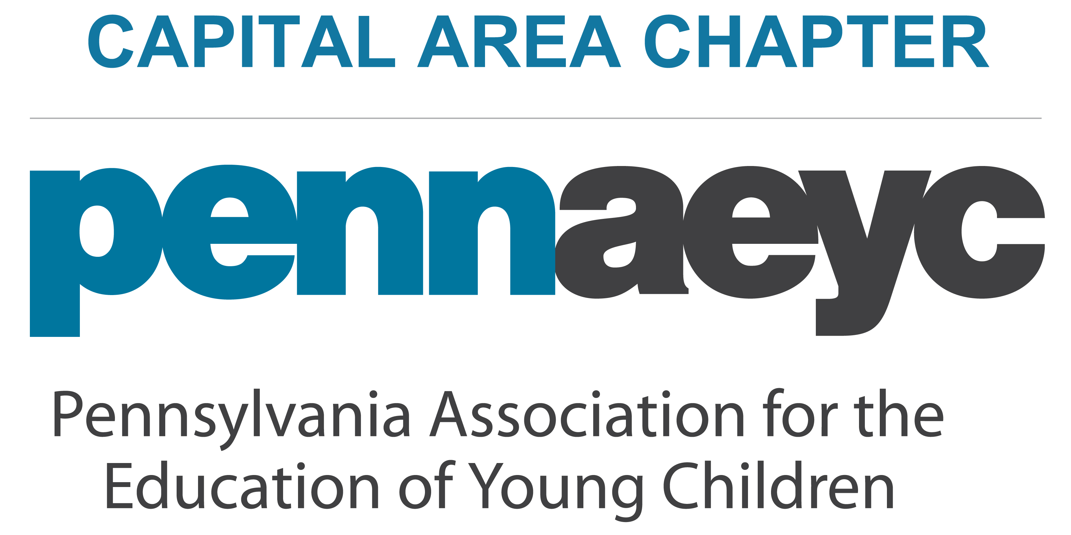
SCHOLARSHIP/TUITION ASSISTANCE APPLICATION

APPLICANT INFORMATION
Please complete each question.

Applicant Information

Name: | Date:
Address:
Phone: | Email:

Employment Information

Place of Employment:
Phone: | Email:
Your Position (administrator, teacher, aide, etc.):
Your Responsibilities:
Name of Supervisor:

Career Plan (if applicable)
Career goal or Credential/Degree Sought:
Current Career Pathway Level: | Level Sought:
Are you registered on the PD Registry? | I have completed a PD Plan:

Course(s) (complete for each course for which you’re requesting assistance)

Name of College, university, educational institution or CDA:
Name of Course: | Instructor/CDA Sponsor:
Contact information for course instructor/CDA sponsor (email or phone #):
Course start date (month/year): | Course end date (month/year):
Tuition cost of the specific course for which you are applying: $
Reimbursement amount requested (maximum $500): $

Name of College, university, educational institution or CDA:
Name of Course: | Instructor/CDA Sponsor:
Contact information for course instructor/CDA sponsor (email or phone #):
Course start date (month/year): | Course end date (month/year):
Tuition cost of the specific course for which you are applying: $
Reimbursement amount requested (maximum $500): $
Name of College, university, educational institution or CDA:
Name of Course: | Instructor/CDA Sponsor:
Contact information for course instructor/CDA sponsor (email or phone #):
Course start date (month/year): | Course end date (month/year):
Tuition cost of the specific course for which you are applying: $
Reimbursement amount requested (maximum $500): $

Additional Funding Sources

Have you requested funds from the PA Rising STARS tuition assistance program?

Yes:__________________ No:___________________ Not eligible:___________________

If you are eligible and have not requested funds, please state the reason why:

Have you received funding from another source for this course? (CDA Assessment Voucher Program, TEACH, other)

Yes:__________________ No:___________________ Not eligible:___________________

If yes, indicate the amount of funding: $

Name of agency/organization that is providing the funding:

I certify that the information on and enclosed with this application is true and correct to the best of
my knowledge.

________________________________________________________________________________ _______________________
Applicant’s Signature Date

SCHOLARSHIP APPLICATION
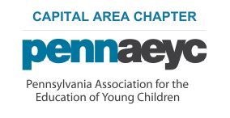

EMPLOYER REFERENCE FORM

1. Name of applicant:
2. Date this form is completed by employment supervisor:
3. Name of program of employment:
4. Address of program:
5. Phone number of program:
6. Name of program director: (employment supervisor)
7. Employment supervisor phone number (s) and best time(s) to be contacted:
8. Supervisor email address:
9. Please write the employment position of the applicant: (teacher, aide, group supervisor, child care provider, administrator, other)
10. How long has this applicant been employed with the program?
11. Is this applicant employed at least 20 hours a week?
12. Describe how this course or credential work will support the applicant’s PD plan and/or career goals.
13. Signature of employment supervisor:

